**Experiment 3:**

**1. Aim:** **Study of network IP Classification of IP address Sub netting Super netting**

**2. Apparatus (Software):**None required.

**3. Procedure:**

The following topics are to be studied under this practical:

1. **Classification of IP Addresses**
2. **Subnetting: Concept with Example**
3. **Supernetting: Concept with Example**

* **Classification of IP Addresses**

IP addresses are divided into five classes: A, B, C, D, and E. Each class is used for different purposes in network architecture. Here’s a classification table for IP addresses:

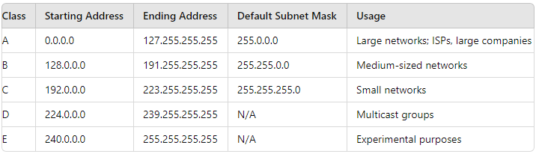

* **Class A:** Designed for large organizations with a significant number of devices. The first octet is reserved for network identification, and the remaining three octets are for host identification.
* **Class B:** Suitable for medium-sized organizations, with the first two octets identifying the network and the remaining two identifying the hosts.
* **Class C:** Intended for small networks, such as small businesses, where the first three octets identify the network, and the last octet identifies the hosts.
* **Class D:** Reserved for multicast communications, allowing a single packet to be delivered to multiple destinations.
* **Class E:** Reserved for research and development purposes.

**Subnetting: Concept with Example**

**Subnetting** is the process of dividing a larger network into smaller, more manageable sub-networks (subnets). This is often done to improve network efficiency and security.

**Example of Subnetting:**

Consider the IP address 192.168.10.0/24 (Class C network).

* **Original Subnet Mask:** 255.255.255.0
* **Subnetting Requirement:** Create 4 subnets.

**Steps:**

1. Convert the subnet mask to binary:  
   255.255.255.0 → 11111111.11111111.11111111.00000000
2. Borrow bits from the host portion to create subnets. To create 4 subnets, we need 2 bits (2^2 = 4).
3. New Subnet Mask:  
   11111111.11111111.11111111.11000000 → 255.255.255.192
4. **Subnets Created:**
   * Subnet 1: 192.168.10.0/26 (Hosts: 192.168.10.1 to 192.168.10.62)
   * Subnet 2: 192.168.10.64/26 (Hosts: 192.168.10.65 to 192.168.10.126)
   * Subnet 3: 192.168.10.128/26 (Hosts: 192.168.10.129 to 192.168.10.190)
   * Subnet 4: 192.168.10.192/26 (Hosts: 192.168.10.193 to 192.168.10.254)

Each subnet can support up to 62 hosts (2^6 - 2 = 62, where 2 is subtracted to account for network and broadcast addresses).

**Supernetting: Concept with Example**

**Supernetting** is the opposite of subnetting, where multiple contiguous networks are combined into a larger single network. This technique is often used to simplify routing and reduce the size of routing tables.

**Example of Supernetting:**

Consider the following networks:

* 192.168.1.0/24
* 192.168.2.0/24
* 192.168.3.0/24
* 192.168.4.0/24

**Steps:**

1. Identify the common prefix: The first two octets are the same across all networks.
2. Combine the networks using a single subnet mask:
   * New Subnet Mask: 255.255.252.0 (/22)
   * Supernet Address: 192.168.0.0/22
3. **Resulting Supernet:**
   * The combined network includes all IP addresses from 192.168.0.0 to 192.168.3.255.

This allows a single route to represent multiple networks, simplifying the routing process and reducing the size of routing tables in routers.

**Conclusion:**

Through this practical, you should have gained a clear understanding of how IP addresses are classified, the concepts of subnetting and supernetting, and how they are applied in network design and management.